INTRODUCTION
The policies and procedures contained in this handbook will provide you with information concerning the operation of Banks Elementary School. This information has been carefully prepared and presented so that it will be of value in helping you perform your responsibilities.
Please follow the recommendations listed so we may have consistency and unity among our staff members. I know each and every staff member will do everything possible to make this year productive and rewarding.
Banks Elementary School will be whatever we make it. Let us always have the spirit and determination to do what is best for our students and our community.

Principal,
Melissa Lynch

MISSION STATEMENT
Banks Elementary will prepare all students for success in the global society utilizing 21st Century Skills, high expectations, engaging instruction, and advanced technology.

To attain this mission we will…
· Operate a safe climate
· Recognize positive behavior
· Promote high expectations within our learning environment
· Incorporate a variety of teaching techniques to improve curriculum and instruction
· Monitor student progress using a variety of assessments
· Communicate effectively within the school and community
· Identify our weaknesses and build on our strengths.

Banks B.E.S.T. - Learning Today, Leading Tomorrow

Table of Contents

Schedules
LCPS Calendar
2017-2018 Master Schedule
Pledge of Allegiance Schedule 2017-2018
Safety Procedures
Fire Drill Procedure
Tornado Drill Procedure
Critical Response/Incident (Lockdown)
Server loss and phone use
Injury or illness of child
Uncontrollable Parent Or Child
CPI Certified Staff- (Uncontrollable Child)
Visitors and Unfamiliar Persons on Campus
Unknown person(s)
Fire Plan Map & Tornado Drill Map Insert
Banks Elementary School
Principal’s Contact Information
ASEOP
Tardies
Reporting Attendance
School-Wide Excused Early-Outs for Events
Reporting Excessive Absences
Withdrawal of Students
Staff School Day
Daily Schedule
Communication
Special Announcements on School Closings and Delays
Announcements
Communication
Mailbox
Email
Voicemail
Google Calendar
Telephone Use
Cell Phones (Calling and Texting)
Students Using Telephone
Class Parties
Receipt Books/Bank Bags
Miscellaneous
Copiers
Facebook
Dispensing Medicine to Students
Student Dress Code
Staff Dress Code
Meetings - Faculty
Committees
Staff Responsibilities
SIT
Grade Level
Field Trips
Volunteers
Cafeteria **Staff members will not be allowed to charge in the cafeteria. Staff may continue to put money on their cafeteria accounts.
Carpool Information and Carpool Tags
Hospitality Fund Guidelines
Duties
Bus
Teacher Assistants Helping Out
Bulletin Board Duty
Reporting Academic Success
Dibels and TRC
Bring Your Own Device (BYOD)
Accelerated Reader/Reading Renaissance
School-wide Plan
Basic Tenets of Reading Renaissance
K-2 Assessment/Writing Portfolio Procedures

Schedules

LCPS Calendar

Master Schedule

Extended Planning Dates

Cafeteria Table Assignments

Early Out Lunch Schedule

Morning Duties

Afternoon Duties

Pledge of Allegiance Schedule 2017-2018

►Teachers shall write their name and their students’ names on a piece of paper prior to sending them to the office.
►Students shall be in the office by 8:05 a.m. each day.

August -September
28- 9/1 Office
--------------------------------------------------------
September
5-8 Office
11-15 Willis
18-22 Smith
25-29 Hill
--------------------------------------------------------
October
2-6 Martin
9-13 Davis
16-20 Sobul
23-26 McCarter
--------------------------------------------------------
November
10/30-3 Daughtry
6-9 O’Neal
13-17 Southerland
20-21 Parks
27-12/1 Potter
--------------------------------------------------------
December
4-8 Barber
11-15 Parrish
18-20 Parks
--------------------------------------------------------
January
2-5 Office
8-12 Oliver
16-19 Deaver
24-26 Isler
29-2/2 Early
--------------------------------------------------------
February
5-9 Beaman
12-16 Jernigan
19-22 Huggins
26-3/2 Griffin
-------------------------------------------------------
March
5-9 Conner
12-16 Kindergarten Teacher
19-23 Taylor
26-28 Moore
-------------------------------------------------------
April
9-13 Sugg
16-20 Arnette
23-27 Willis
30-5/4 Smith
--------------------------------------------------------
May
7-11 Hill
14-18 Martin
21-25 Office
29-6/1 Office
--------------------------------------------------------
June
4-7 Office
Safety Procedures

Fire Drill Procedure
** Required- Maps are to be posted at interior and exterior doors along with updated student rosters.

Signal: The fire alarm is a continuous alarm that sounds along with emergency flashing lights, and hall doors automatically close. If the electricity fails, someone will notify each class.

Action: When the alarm is sounded, pupils are to heed their teacher’s directions and rise, walk quietly and quickly out of the room. Students are not to carry anything with them. No running, talking, or pushing is allowed. Teachers should account for all students once you are outside. Teachers are to carry out an updated student roster to ensure all students are accounted for. Staff and students will remain outside until a school official gives the all-clear signal. Please follow the exits as marked on your map.

Each teacher will need to count their children when they arrive in their area outside. If a student is in attendance and not with the class, the teacher will hold up a RED card. If all students are with the teacher, she will hold up the green card. The principal and Taylor will use radios to locate the students that are not with their homerooms.

Fire drills are required within the first ten days ( First fire drill- August 31 @ 2:30 pm) of school and on a monthly basis.

Fire Drill Duty Stations
Media hall, Gym, Storage area, EC area, Cafeteria - Taylor/ Wendy Piro
4/5 hall and restroom-Melissa Lynch
2/3 hall and office- Custodian
K/1 hall and mobile units- Custodian
Front of Building-Jones
Back-up- Andrews or Hoffman

Tornado Drill Procedure
Signal: Verbal Announcement
Action:
- For a WATCH: Classes that are outside should move inside and all movement is restricted.
- For a WARNING: Teachers and students move immediately to the designated shelter areas and assume fetal positions with hands over head. All clear signal=verbal and /or staff communication.

Updated maps will be provided at the beginning of each school year.

Critical Response/Incident (Lockdown)
In the event of person(s) coming on campus with the obvious intent to harm a student or staff member, all steps will be taken to communicate this information to you and insure everyone’s safety. An all-call will be attempted, otherwise we will notify you somehow if at all possible. When you hear this announcement: “lockdown ”—stay in place and follow the procedures that we have discussed in our “Critical Response Training”. “lockdown yellow” is for drills and “lockdown red” is the real thing. For obvious reasons—do not communicate the danger to the students. The office staff or law enforcement will let you know when everything is clear or your next steps.

Server loss and phone use
In the event that the server goes down, the following phones will continue to call out.
Principal, Jones, Taylor, Testing Office, Reception, EC Compliance Office, Guidance Office, Sobul, Arnette, Griffin, Cafeteria

Concussion and Head Injury
LCPS Policy: 4270/6145
Minor Injury—treat if possible with classroom first aid kit. If not, send to office with another child. The school nurse is available on Mondays, Wednesdays and Fridays.
Major Injury - DO NOT MOVE THE CHILD
- Send another child to the nearest adult for help.
- Administer first aid.
- Contact office. (Always notify principal)
- Contact parent or guardian.
- Contact emergency services if needed.

Note: Always call parent if head or neck are injured, no matter how slight you may think it is. It is required that any injury to the head or neck it reported using the LCSP Accident Form. The form must be submitted to the principal. The principal will then submit it to the Central Office.

Uncontrollable Parent Or Child
LCPS Policy: 1510/4200/7270
- Isolate the parent or the child. If Possible, ensure that another staff member stays with you at all times.
- Find another adult to go for help or designate a child, if no other adult is available to go for help to the nearest adult or office.
- Notify principal

LCPS Policies for Review
6315 Drivers
1720/4015/7225 Discrimination, Harassment & Bullying Complaint Procedure
1710/4021/7230 Prohibition Against Discrimination, Harassment and Bullying
7240 Drug-Free and Alcohol-Free Workplace
7241 Drug & Alcohol Testing of Commercial Motor Vehicle Operators
7335 Employee Use of Social Media
5026/7250 Smoking and Tobacco Products
1510/4200/7270 School Safety
5027/7276 Weapons and Explosives
7300 Staff Responsibilities
4040/7310 Staff-Student Relations
7510 Leave
7520 Family & Medical Leave
7530 Military Leave
7565 Excessive Absenteeism
7900 Resignation
QP-C-014 Code of Ethics for North Carolina Education

CPI Certified Staff- (Uncontrollable Child)
Staff members who are certified in CPI- Physically Out of Control Students
- Andrews
- Isler
- Lewis
- Griffin
- Harper
- Atkinson
- Bennett
- Murray
- J. Smith
- Martin
- Jernigan
- Murphy
- Parks

At no time should a staff member hold a student unless they are CPI trained and has a witness with them. All holds must be documented and turned into the principal within 24 hours.

Visitors and Unfamiliar Persons on Campus
LCPS Policy: 5020
- All staff members will wear a photo identification badge daily and carry LCPS swipe cards to ensure entry.
- Staff should use a scan card to enter the mailroom door. A key should not be used at any time. This door must remain locked at all times.
- All visitors who have checked in at the office will wear a Banks official visitor’s sticker. All visitors will be required to check in and out in the office using the electronic system.
- All exterior doors should remain locked throughout the school day.
- No adult should go directly to the classroom and interrupt the educational process. Students will not be called to the office to see visitors unless it is an extreme emergency.
- Kindergarten and first grade hallways should remain locked throughout the day.
- Kindergarten and 1st grade teachers will need to greet students at the hall door promptly at 7:50 a.m. daily. Students will be monitored from the front door. Parents should not escort students to class using the interior hallway.
- Students in 1st grade should always travel in pairs and have a swipe key to re-enter the 1st grade hall. At no time should any kindergarten or 1st grade student walk from building to building by themselves.

Unknown person(s)
Staff should always inquire if they need assistance and ask him/her to report to the office to sign-in and receive a sticker. If the visitor refuses to go to office, go to nearest phone and inform office of non-compliant visitor and his/her location.

Tornado Drill Map

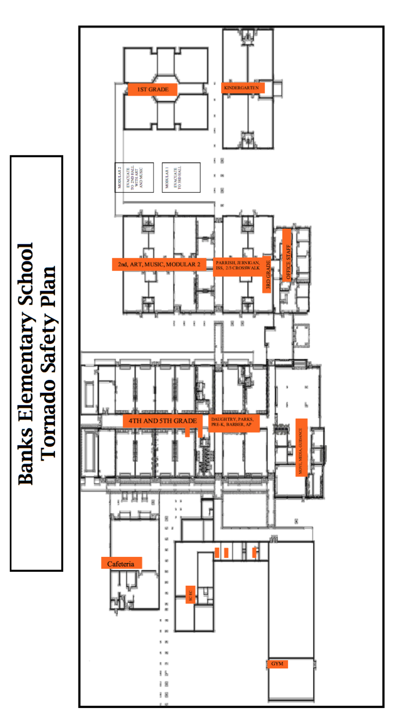

Fire Plan Map
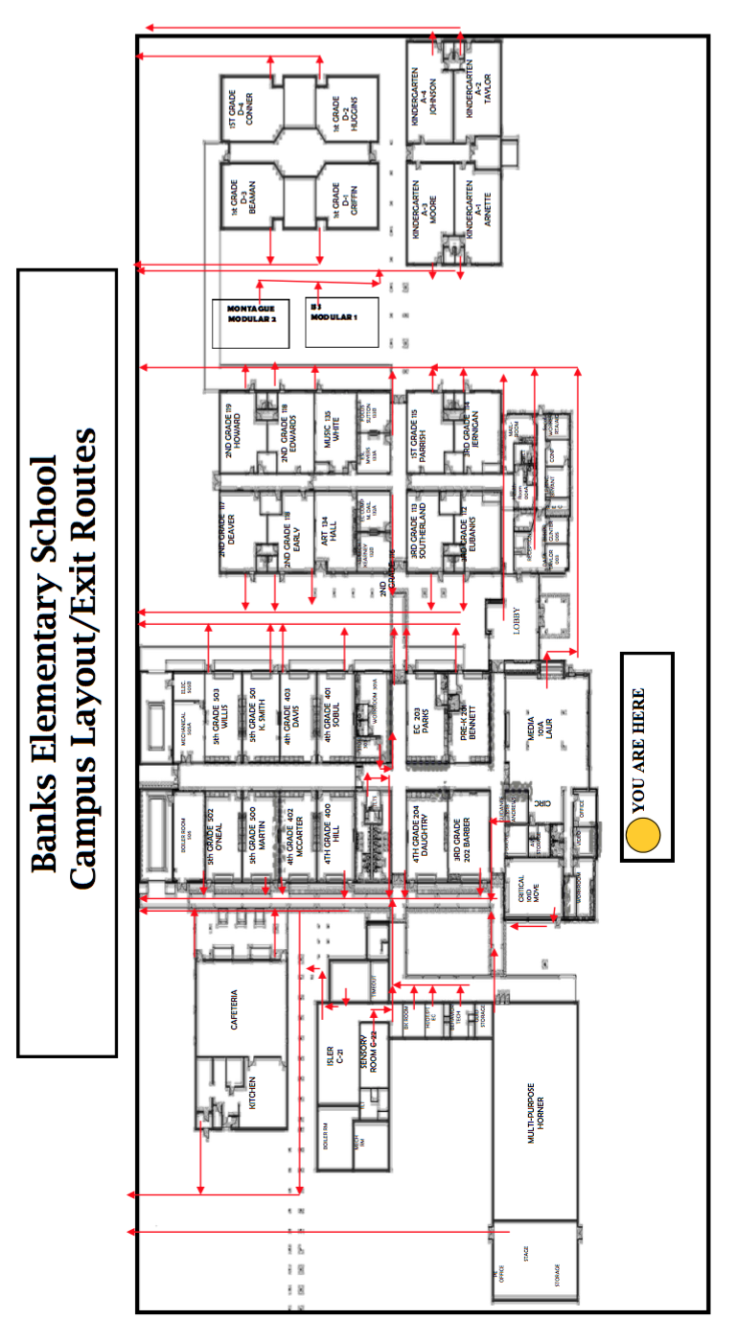

General Information

Banks Elementary School
2148 Falling Creek Road
Kinston, North Carolina 28504

LEA Code 540 School Code 304

Main Number 252-527-9470
Phone 252-527-6599 (choose an ext.)
FAX 252-522-9714

Principal’s Contact Information

Melissa Lynch
Work 252-527-6599 x 1920
Cell 919-222-4790

AESOP
1-800-942-3767
www.aesoponline.com and can be accessed through LCPS website under STAFF
Please follow directions for securing substitutes. If after 6:50AM, load request for ½ day PM. (11:30 AM-3:30 PM) Coverage will have to be made until your sub arrives. Call school and leave a message if that is the case. AESOP will send a report to office staff and admin daily.
Your ID Number is your telephone number and your password is the last 5 digits of SS#. Substitutes want to know who and what they are subbing for. Please login and update your title. Click on ACCOUNT and update your title. Do not use numbers-spell out your title. Example Exceptional Children not EC or Fifth not 5th.

***You are encouraged to add your “Preferred Subs” to your personal list. These subs will see your absences much earlier than if you use the school’s preferred list. If you have no preferred list, then there is no guarantee who will be your sub. The school’s preferred list will be contacted by telephone but if a sub logs on, they can see all the available jobs.

Student Attendance

Tardies
Students will be considered tardy if they arrive after the 8:10 a.m. tardy bell rings.
- Parents ARE REQUIRED to sign students in using the electronic system in the main office.

Reporting Attendance
- Attendance should be taken, coded and marked complete by 9:00 a.m.
- Please be reminded that all students are either present, absent or late. All attendance and lates default to “Unexcused” unless the student has had a prior approval for an absence from the office which you will receive notice of this as well as for other reasons for absences such as suspension for which there is a code in PowerSchool. If a student comes in late before you have coded your attendance, you may code that student as “Unexcused Late”. Please be reminded that at any time, changes can be amended by you prior to you completing your daily attendance.
- Data Manager sends attendance letters weekly. It is imperative corrections are made to attendance by teacher as absentee/doctor notes are received from parents. We do not want to send incorrect attendance letters to parents for student absences.
- Please follow the 3- day rule for changing any Unexcused absences to excused (students must present a note by the 3rd day that the child returns to class- in student handbook). If you have any questions as to the code for an absence, consult the principal.

Students Checking Out Early
- Students who are checking out early must have a parent sign them out.
- Another adult checking out a student must have a note from the parent.
- Students will be called to the office if leaving before 2:00.
- Parents will use the electronic system to sign out students.
Students will not be called to the office to leave school after 2:00 p.m. in the afternoons.

Exceptions to this policy will be made for the following reasons:
- Emergency situations
- Presentation of a doctor/dentist appointment card
- A prior written notice indicating the time the child will be picked up.

School-Wide Excused Early-Outs for Events
Students will NOT be coded as an early-out if there are leaving after a school wide event such as AR parades, awards days, and approved class parties (Christmas, Easter, and End-of-Year).
- Siblings are not excused from class to attend parties, field trips, parades or awards days. Only exception is Kindergarten completion and 5th grade graduation ceremonies.

Reporting Excessive Absences
All students returning from an absence must present a note explaining his/her absence(s) by the third day of their return to school.

If the parent calls to let you know why the student is absent, a note is still required to document the excused absence. The classroom teacher is charged with the responsibility of making sure all absences are coded correctly in PowerSchool.

- When a student is absent for 3 consecutive days and no reason is known---the homeroom teacher should call parent to ascertain reason for absence. Please remind the parent to send a note with the student when he/she returns to school. Discussion on the phone does not constitute documentation of an excused absence.
- Please let Mrs. Taylor know if the three days of consecutive absences are unexcused, so she can send the legal documents to parents/guardians.
- If step 1 proves unsuccessful, or habitual absences become a problem, fill out the referral form for the school social worker.
- Copies of this form can be found in the mailbox room. Place your completed form in the social worker’s mailbox. The social worker will investigate and give you feedback.
- The administration will follow the compulsory attendance law and send out the appropriate letters.

Withdrawal of Students
When a student withdraws from your class to another school, either within this LEA or an outside LEA, Mrs. Taylor will give the teacher a withdrawal form for books and clearance of debts. The teacher will pass to all areas of the school to check for all books turned in and all debts cleared. Within 5 school days after the final attendance date, the homeroom teacher should turn in completed cumulative folder to Mrs. Taylor. Teacher must include copy of most recent report card, attendance information, and AR information in cumulative folder. If the child is EC, then the EC teacher should make sure all CECAS information is up-to-date and make copies if students are leaving Lenoir County.

Staff School Day
The length of the school day for all teachers is 7:45 a.m. - 3:30 p.m. unless otherwise noted.
- Certified staff members who work carpool duty or a.m. bus duty- work day is 7:40-3:25.
- All staff members may be asked to sign in if these times are not adhered to.
- All classified staff members will use the TACS time keeping system.
- Any changes in TA schedules must be approved by the principal prior to time changes being made.
- Non-bus driver TA’s schedule for morning duties start at 7:40. Workday 7:30-3:15.
- Required Workday hours are 7:45 a.m. - 3:30 p.m. with 1 hour 15 minute lunch (unless involved in district professional development where you must adhere to their schedule).
- Optional Workday hours are 8:00am - 3:30pm with 1 hour 15 minute lunch or you may work through lunch to leave early and certified staff must sign in at the front office on Optional Workdays.

Teacher and Assistants hours- 7.75 (7 hours, 45 minutes) daily
TA/Bus Driver- 7 hours TA time, remaining time is bus time
**TAs must return to work on early-out days.
Each afternoon before leaving, teachers must verify the classroom doors to the outside are secured and locked.

Daily Schedule
7:40 a.m. Carpool students will report to the media
center (K-5) or directly to the cafeteria if picking up breakfast (1-5).

7:50 a.m. Students dismissed from the cafeteria (1-5)
will report to classrooms. Doors must be open at 7:50 a.m. for breakfast students exiting cafeteria only and teachers must be at doors to welcome students. 1st Grade Main Building Door must be manned by a teacher (rotation) and opened at 7:50 a.m.

7:55 a.m Students dismissed from buses and Media
Center. Kindergarten Main Building Door must be manned by a teacher (rotation). Doors must be open at 7:55 a.m. and teachers must be at doors to welcome students.

8:05 a.m Staffing at the carpool line ends.

8:10 a.m. Staff hallway and breakfast duty ends.
Tardy Bell Rings.

8:10 a.m. Announcements and classes begin.

2:50 p.m. Announcements and dismissal K-5 carpool
Dismiss bus riders 1, 3, 5

2:55 p.m. Dismiss bus riders K, 2, 4

Cafeteria Lunch Coverage Plan and Expectations

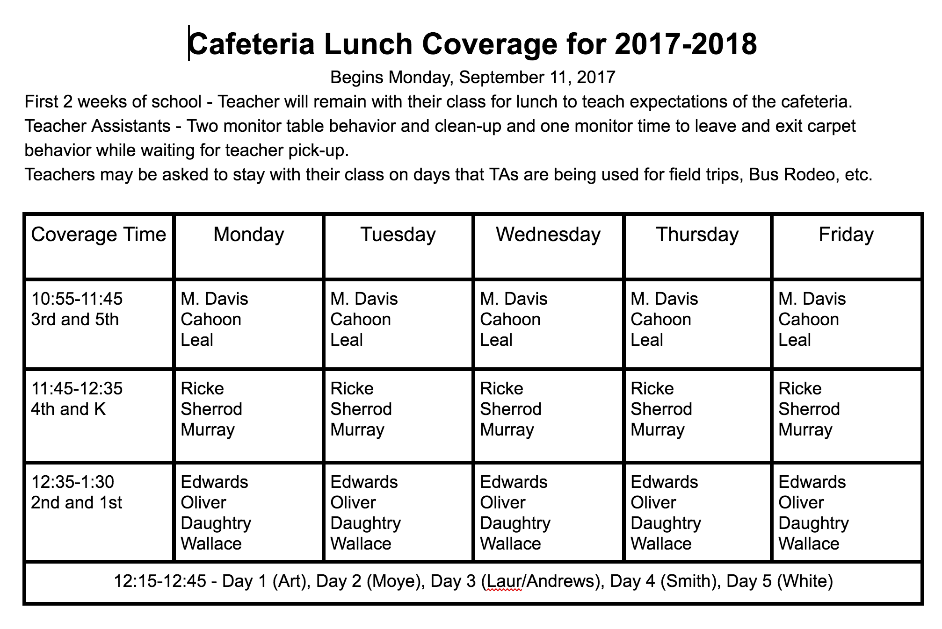

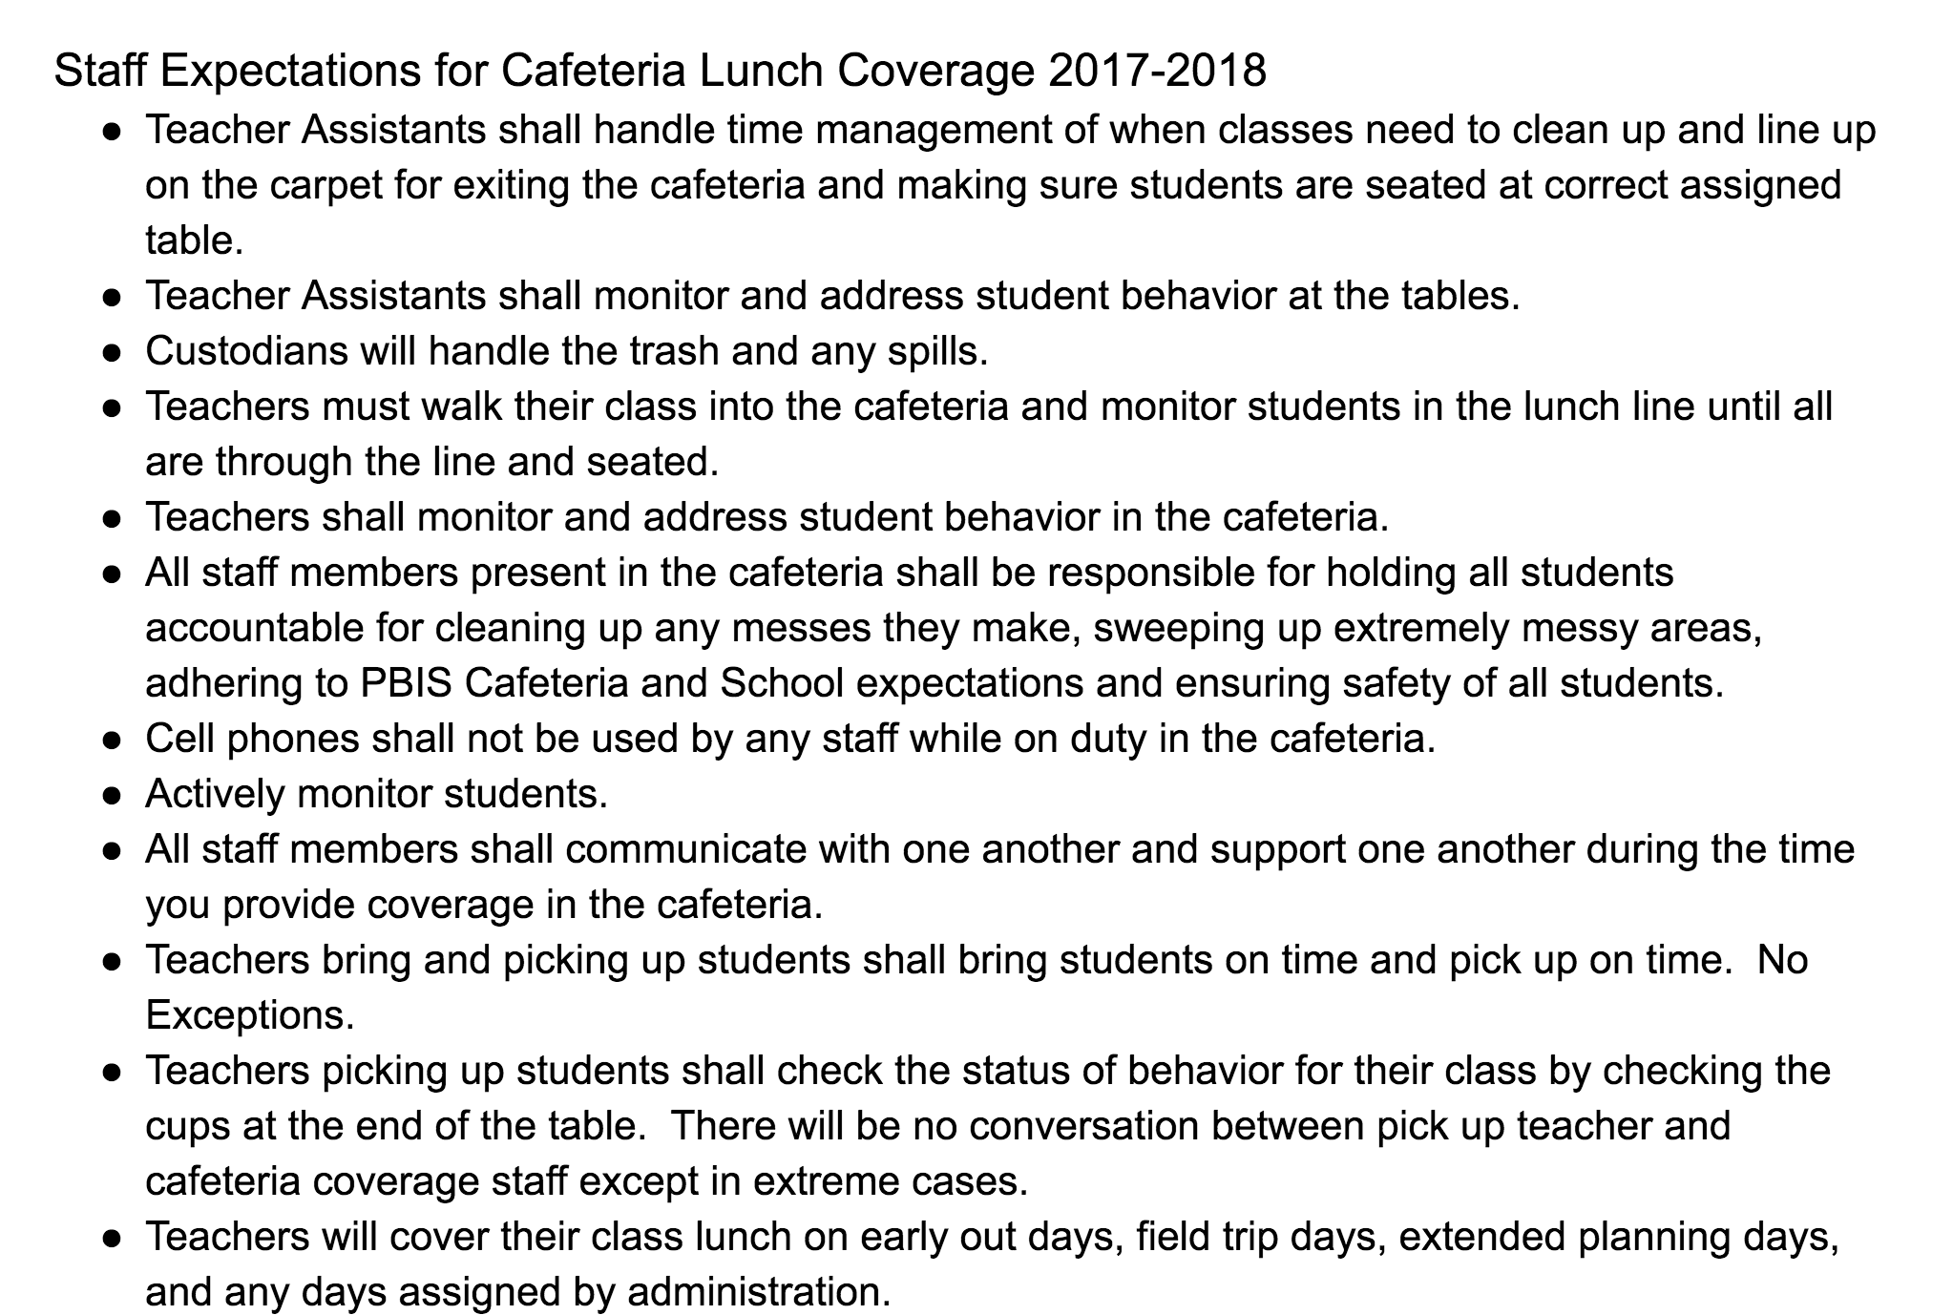

Communication

Special Announcements on School Closings and Delays
Special announcements on school closings or delays due to weather conditions or other causes are made on radio stations WELS (1010AM/102.9), WIKS (102FM), WNCT(1070AM/107.9FM), and WRNS(95.1FM), cable television channels 8, 10,and 13 and LCSP website. Connect-Ed will be used to communicate school closings, special announcements, etc.

Announcements
All messages to be announced in the a.m. and p.m. should be submitted to the office in written form including students names that are reciting the Pledge of Allegiance.
- AR, Honor Roll, Principal’s List, PBIS Student of the Month- All teachers are expected to turn in names for the above on the Google Forms available for each. Reminders and announcements are made to ensure all staff have ample time to get their names in. Make sure you turn your list in on time in the google form provided for you!!!

Communication
Staff members have a mailbox, email and voicemail for receiving information. Staff members are required to check their mailbox, email and voicemail upon arrival at school, during the day and before dismissal to make sure all messages are received in a timely manner.

Mailbox
Check your mailbox upon arrival, during your break, and after dismissal.

Email
Check your email on a daily basis for important LCPS and principal messages.

Voicemail
Please be respectful of all staff including the office staff by leaving a voicemail for NON-EMERGENCY messages. Use *ext. number. Staff members must check their voicemail before dismissal for important transportation information. In the event you are absent, teachers need to leave their passcode for their voicemail posted near their telephones.

Confidentiality
Student, parent, and situational issues should not be shared between staff members who it does not pertain to. Talking about issues in front of other students, parents, or individuals is not acceptable and leads to mistrust among staff and the community. Make sure that important information is shared only with staff members who it would benefit and that it is done is a professional manner.

Google Calendar
All staff members are expected to check the staff school calendar online to get specific dates of events and other important information. You may check it online at any time.

EC Google Calendar
EC teachers will schedule all IEP meetings using the google calendar to ensure an LEA is available and so that meetings do not overlap.

LEA- 2017-2018 - Principal

Weekly Memo
Each week the Weekly Memo is updated for all staff to see what is happening for the upcoming week(s) in detail. Please submit items needing to be added for the next week by Friday at 3:30pm to the principal via email. It is the expectation that all staff review the weekly memo to stay up to date on weekly events at Banks

Telephone Use
Teachers are encouraged to use their room telephone for conferencing by phone with parents. Staff members are discouraged from receiving or placing personal telephone calls during the workday.

Cell Phones (Calling and Texting)
Personal cell phones should not be heard nor seen during the day. All phones should be on vibrate if they are carried. At no time should a staff member be seen using their cell phone during the instructional part of the day or in the view of a student (calling, texting or any other instant messaging). All staff and faculty members should limit the personal calls made or received during their workday.

Students Using Telephone
Students should not be allowed to call home for homework, books, etc. Teaching students to be responsible is important. Glasses, prescription medicines are “must haves,” so teachers should call parents to bring these items to school. Even these items should not be left home on a regular basis. Please emphasize to students the necessity for planning after school activities with parents before the school day begins. Students should not telephone parents to gain permission for going home with someone else or staying after school for a prior planned activity, etc.

Class Parties
Class parties may be held at Christmas, Easter, and at the year-end. Birthday and other holiday snacks brought by parents may be eaten after 1:00 pm. Teachers DO NOT have permission to make exceptions for any reason.

Receipting Money and Bank Bags
Teachers are responsible for their receipt books. Please receipt and turn in all money in a timely manner. Only keep in your classroom the amount of money that you can replace if lost or stolen. A security drop box labeled STAFF DROP BOX is for bank bags and is located in the mail room beside the mail boxes. Please use this box instead of placing bank bags in Mrs. Jones’ mailbox. Do not put items to be shredded in this box.

Gift Bags
Parents are allowed to provide gift bags for the students during various celebrations. Teachers are required to look into the bags before handing them out to ensure all items are appropriate for students. Teachers do not have to check every bag but be aware of the contents being given.

Siblings attending parties and awards
Siblings are not to attend other siblings parties/snacks/ awards during the year. Siblings may be excused from class to attend kindergarten completion and 5th grade graduation. These are the only exceptions.

Miscellaneous

Copiers
Each teacher is given 22,500 copies. Please be aware of what you are using. Worksheets are to support meaningful instruction, they are not engaging for students!. Use your copies wisely.
- Please be aware of others needing to make copies during the day and if they have TAs in the classroom. Time is limited for all of us and we can not tie up a copier to run items for a week when others are waiting!!!!

Read to Achieve Copier
All 3rd grade teachers will use the front office copier to run off Read To Achieve passages only. A separate code will be given for these passages. Teachers will be responsible for running all instructional and assessment passages for their class. Each teacher will be provided one copy of all of the passages to secure in their rooms for easy accessibility. All passages must be kept in a locked cabinet.

BE ON TIME!!!!
All classes are to arrive on time and be picked up on time to and from lunch and specialist classes. Schedules are developed to ensure all students have ample time for eating and receiving educational instruction in our specials classes. Being late dropping off or picking up affects the entire school and limits teaching time for our specialist.

Facebook
Be reminded that you are a role model in the community and what you put on facebook is public knowledge. Do not post anything that you would have to explain to an administrator or parent. Staff are not to be on Facebook during working hours. Be cautious about befriending parents.

Banks Facebook Page
The Banks Elementary Facebook page is maintained and updated by the Principal, Hood, and White. Teachers who wish to have posts made to our FB page will need to submit those to Hood, White, or the principal.

Pinterest
Pinterest is accessible to all classroom teachers. This site should not be searched during instructional time. LCPS has created educational boards on their website for teachers to be able to access as well.

Employees’ Children
Employees who have their own children arriving early or staying after student hours with them should require the children to remain in their classrooms/offices at all times. Do not allow your child to run all over the campus without your supervision. Thank you for making other arrangements for your children when you must attend meetings. Students should not attend meetings with you due to confidentiality and the need for your undivided attention in meetings. Employee’s children are not to be in the mailroom or workrooms as well due to confidentiality. Thank you for adhering to these guidelines.

Teachers Who Tutor
Teachers who charge a fee for tutoring students, should not begin tutoring sessions until after their working hours are finished. Tutoring sessions should not interfere with your duty to attend committee, grade-level, or faculty meetings, etc. Tutored students should remain in the teacher’s classroom until the parent picks them up.

Dispensing Medicine to Students
With parent permission and the correct forms completed, prescribed medication can be given to students. The medicine should be dispensed by the teacher and kept under lock and key in the teacher’s room. The proper medicine log should be completed on a daily basis. A current form from the doctor should be on file with the log. These forms can be found in the cubbies in the mailroom. At the end of the school year, the permission form and log should be given to the nurse. Leftover medicine should be turned in to the nurse or Mrs. Taylor. Bottles of medicine should never be given to students to take home.

Head Lice
LCPS Policy: 4235/6135
The management of Pediculosis (Head Lice) should not disrupt the education process or interfere with student learning.. Staff will screen for head lice when necessary or on an as needed basis. Random screens will be held throughout the year as directed by the principal. Only parents of affected students will be notified if head lice or nits are found. Students who only have nits may continue to be in the classroom throughout the day. Students that have live bugs will be sent home until treated. All parents will be notified if their child has nits or live bus along with treatment and regulations.

Student Dress Code
LCPS Policy: 4316
Non-Comp School Dress Code Form Parent Notification Form
All students must observe the following guidelines: Revised 6-2013

1. Shorts, skirts, and dresses must be at least knee length for middle and high school students. Elementary students may wear shorts, skirts, and dresses no higher than three inches above the knee.
2. Shirts and tops should be high enough to cover the chest. No sleeveless shirts or tops are allowed at the middle and high schools. Tank tops, spaghetti straps, tube tops, halter tops, see-through shirts, mesh shirts, and clothing that expose the midriff or chest are not appropriate nor allowed. Shirts and tops should be without non-functional holes. Undergarments should not be seen. - Sleeveless is allowed in the elementary setting, no tank tops!
3. Clinging or form-fitting clothing (pajamas, leggings, jeggings, yoga pants, etc.) are not permitted.
4. Pants and shorts must be properly fitting and fastened at the waist. Pants, shorts, skirts, and dresses must be without non-functional holes above the knee. No sagging pants are allowed. Undergarments must not be seen
5. Clothing, jewelry, emblems, badges, symbols, signs, visible tattoos and body markings, or other items that are vulgar or obscene, encourage illegal drug use, or depict gang affiliation are prohibited. Each principal shall, in consultation with the local police department, compile a list of current gang symbols. The items on this list shall be considered to depict gang affiliation and shall be prohibited. This list shall be frequently updated and publicized to the students whenever changes are made.
6. Appropriate footwear must be worn at all times. Footwear must be properly laced, tied, buckled, and fastened at all times. Appropriate footwear is that which can be worn safely and without distraction in the school environment without fear of injury to oneself or others. Bedroom shoes are not allowed.
7. No sun/shade glasses are to be worn in the building unless it is medically prescribed that they be worn indoors
8. No hats or caps are allowed. Hoodies/hooded coats are allowed but hoods cannot be worn inside the building. No head gear (bandanas, kerchiefs, curlers, doo-rags, hair wraps, etc.) is to be worn unless required for religious or medical reasons. Toboggans are allowed outside.
9. Schools may exceed or clarify this dress code policy with approval of the superintendent and board notification.

Staff Dress Code
LCPS Policy:7340
• All instructional personnel and support staff must observe the following guidelines:
•1. Shorts, skirts, and dresses must be at least knee length. Professional dress shorts may be worn at knee length. Skirts and dresses that contain slits can be no longer than three inches.
•2. Shirts and tops should be high enough to cover the chest. No cleavage should be seen. Tank tops, spaghetti straps, tube tops, halter tops, see-through shirts, mesh shirts, and clothing that expose the midriff or chest are not appropriate nor allowed. Shirts, tops, and dresses should be without non-functional holes. Undergarments should not be seen. Shirt and tie, or dress shirt or knit shirt with collar is required for men during classroom instruction time and shirts must be tucked in.
•3. Clinging or form-fitting clothing (pajamas, leggings, jeggings, yoga pants, etc.) is not permitted.
•4. Pants and shorts must be properly fitted and fastened at the waist. Pants, shorts, skirts, and dresses must be without non-functional holes. No sagging pants are allowed. Undergarments must not be seen. No denim is allowed.
•5. Clothing, jewelry, emblems, badges, symbols, signs, visible tattoos and body markings, or other items that are vulgar or obscene, encourage illegal drug use, or depict gang affiliation are prohibited. Jewelry affixed to an employee’s nose, tongue, cheek, lip, or eyebrow is not permitted.
•6. Appropriate professional footwear must be worn at all times. Footwear must be properly laced, tied, buckled, and fastened at all times if they are manufactured with laces and buckles. Appropriate footwear is that which can be worn safely and without distraction in the school environment without fear of injury to oneself or others. No flip-flops or beachwear is allowed (Rainbows, Crocs, etc.)
•7. No sun/shade glasses are to be worn in the building unless it is medically prescribed that they be worn indoors.
•8. No head gear (bandanas, kerchiefs, curlers, doo-rags, hair wraps, etc.) is to be worn unless required for religious or medical reasons.
9. Schools may exceed or clarify this dress code policy with approval of the superintendent and board notification.

Meetings - Faculty
Banks staff and committee meetings will be held most Wednesdays.
- Staff Meetings - Wednesday once a month
- PBIS Meetings - Tuesday once a month
- SIT Meetings - Wednesday once a month
- SIT subcommittee meetings - Wednesday once a month
- Grade/Department Chair Meeting - Scheduled by Grade Levels
- PLC Meetings - Mondays twice a month
- Digital Learning Lounge - Tuesdays twice a month
All teachers and assistants are expected to be present. Please keep Wednesdays free of parent conferences and personal appointments. Please let the principal know if you need to present information to the staff prior to the staff meeting so that you can be added to the agenda. The length of all meetings depends on agenda items.

2017-2018 Committees
Your active participation on committees is crucial to the success of Banks Elementary.

2017-2018 Staff Responsibilities

SIT (NCSTAR)
NCStar serves as the School Improvement Plan process. The link and Guest Login Information will be available on the Banks Page for parents and community members to view our plan. To view the Banks Comprehensive School Improvement Plan you will need to visit www.indistar.org and use the following login information:
Guest Login
Username - GuestS15407
Password - GuestS15407

K-12 Standards, Curriculum and Instruction (DPI WEBSITE)

LCPS INSTRUCTIONAL GUIDES AND RESOURCES (LCPS WEBSITE)

ECU Educator Library Card
As a resource to the continual professional development growth of teachers in LCPS, ECU is offering the Educator Library Card which provides free access to all the library materials at ECU. This free access is being offered to teachers in Lenoir County and selected districts.

Here is the information on the Educator Library Card: Link: http://www.ecu.edu/cs-lib/trc/educard.cfm

The teaching resource library can be particularly helpful: http://www.ecu.edu/cs-lib/trc/

Extended Planning Days
Extended Planning days will be held on Thursdays for the 2017-2018 school year. Each grade level will have two full days of extended planning. During these days staff are required to plan together, be involved in PLCs, and/or participate in teacher-to-teacher trainings. This day is not to be utilized for paperwork or catch up. Staff may wear jeans during their scheduled extended day and one staff member will be allowed to leave campus to pick up lunch. After each planning day, agenda/meeting minutes must be turned into the principal.

Issuing Textbooks and Collecting Fees
The issuing of textbooks and collecting fees for damaged and lost books will be the responsibility of the teacher who issues the texts. Please make sure each textbook has a sequential number plus the year the textbook was first issued. The number should be written on the inside cover in the appropriate space. (Example—this year all newly added books and materials should be numbered sequentially in this manner: 1-07, 2-07, 3-07, etc.) Teachers should write their last name in the textbooks they issue, so lost texts can be easily returned. At the end of this section is an updated price list for textbooks. Also the textbook record form should be completed by the teacher when the textbooks are issued.

Procedures for Prior Approval of Staff Development Opportunities
Staff members are expected to participate in all professional development that is offered on required days. Professional development on the individual level is based on need and availability of the professional development. Staff members are expected to complete the SEA System and all follow up surveys to be awarded renewal credits.

- SEA system information must be completed for all staff development activities.
- The entire form must be completed online and will automatically be sent to the principal and appropriate supervisor.
- Participants will receive an e-mail once the principal and staff development director has approved application.
- Please give Mrs. Jones a copy of the “APPROVED” SEA System application and your Employee Absence Request form. Load your absence into AESOP if required.
- When the staff development activity has been completed the participant should complete all surveys in SEA System. Reimbursement requests, etc. are within the SEA System survey.
- Always make and keep a copy of every form and write on them the dates that you sent them to the school office or director’s office.

Renewal Credits
Staff members are responsible for maintaining enough renewal credits for a cycle.
Visit http://www.dpi.state.nc.us/licensure/update/ to update or renew your professional educator’s license. Information about renewal credits, the new Online Licensure System, and renewal criteria are all included at the site.

E-PAY for Staff Payroll
You will need to go on the Epay Portal to view your checks. The Epay Portal is located on the LCPS website under staff. Epay may not work at home if your browser is not current.

Field Trips
Field trips are valuable learning experiences and are encouraged. At the beginning of each year, grade level teachers should investigate and decide which grade level trips will be taken. Dates should be chosen and plans made.
- The prior consent of principal and /or superintendent should be obtained by completing the proper form located on the website. All information must be typed and submitted to the field trip designee electronically. Please note the educational objective of the trip is included.
- Chaperons- All Trips must abide by the 1:10 ratio rule.
- All EC students who are served in the separate setting or have additional special needs will need additional coverage during any trip. EC students are not to be excluded due to disability.
- Buses- Bus drivers’ names will be included by the field trip approval designee
- Forms will be turned in electronically to the field trip designee. Once approved, they will be submitted to Central office electronically.
- After permission is granted, then parents should be informed. To avoid overlapping trips, grade chairs should share trip plans with each other. If you are planning multiple field trips, then teachers should keep on file the insurance information for each child instead of asking the parent for it each time.

Mrs. Taylor and Ms. Wendy Piro will procure activity buses, yellow school buses and/or drivers for field trip transportation. If you are traveling to another state institution within the county, then yellow bus transportation may be an option. Correct forms are located on the LEA website.
- Always notify the cafeteria manager if your grade level or class will miss lunch at school.
- Assistants missing lunch duty because of field trips must notify their lunch buddy teacher. Teachers are then responsible for their own class at lunch. This includes escorting and staying with them to maintain discipline.

NOTE--TEACHERS/BUS DRIVERS MUST NOTE BEGINNING/ENDING MILEAGE IN ORDER TO ESTIMATE COST OF BUS ON THE BUS FORM.

Activity bus mileage $1.25 per mile (NL or bus garage bus) Yellow Bus Use (Inquire about cost)

** Trips costing less than $5.00 will not be refunded if due to sickness or behavioral issues. Please put this on your field trip information letters to your parents. Also indicate that all students and parents must abide by the procedures, rules and regulations and the dress code that has been set up for the trip.

Forms to be turned into principal prior to a field trip: Field Trip approval form and Activity Bus Invoice (if using the activity bus).

Volunteers
Volunteer approval process is located here: https://docs.google.com/a/lenoir.k12.nc.us/document/d/1qU8cppFcztC-q71W3JO8bn0ipHHdmJqgAnI6-Jyj21s/edit?usp=sharing
If a parent, family member, or friend of the family is coming on campus for school or class events, parent nights, class parties, conferences, or attending a field trip with your child’s class, they DO NOT have to complete this volunteer process. The volunteer approval process is for individuals wanting to volunteer their time during the school day working with teachers and students. The approval process is good for 2 years.

Cafeteria **Staff members will not be allowed to charge in the cafeteria. Staff may continue to put money on their cafeteria accounts.

Carpool Information
All carpool information is provided at the beginning of the year. If you need additional copies, they will be placed in the mailroom.
Carpool Tags
Reminder-Parents should complete and return the carpool tag request form prior to you sending home carpool tags. Please only send home the number that they request. Keep your copy of the request in case that information is needed.

Hospitality Fund Guidelines
The Hospitality Fund is an important fund that is used for specific events. Hospitality chairs will have the opportunity to update and change criteria as needed. Effective communication is imperative so that the committee can fulfill the guidelines as outlined below.
In addition, the “About Us” board in the mailroom is not the responsibility of any one person—all staff members are welcome to write information that needs to be shared on this board. Please do not tape anything to this board. All members of the staff and faculty are expected to contribute to the hospitality fund in order to participate in all aspects of the fund’s sponsored events. The events sponsored and paid for by this fund include showers, holiday potluck, faculty lunches, Christmas party, TOY flowers, door prizes, end of the year celebration and other events as necessary. In addition the fund will cover the following items:
- Flower Fund
  - $25.00-30.00 flowers for hospital stay of three or more days.
  - $35.00-40.00 flower arrangement, plant or wreath to staff member with death in the immediate family. (husband, wife, father, mother, or child.)
- Baby and Wedding Gifts
  - Hospitality Chairs will be responsible for collecting money from staff to purchase a gift from the staff for the first time moms, dads or brides and grooms.
  - A gift from the staff will be presented to all second time moms, dads or brides and grooms. ($25.00)
- Departing Staff Member
  - Less than one year at Banks---card
  - 1-2 years - $15.00 gift
  - 3-5 years - $20.00 gift
  - 6-10 years - $25.00 gift
  - 11-19 years - $30.00 gift
  - 20 plus years - Gift suited to the individual ($50.00)
- Miscellaneous Gifts
  - Teacher of the year – flowers/plant
  - Teacher Assistant of year--flowers/plant
  - Support Staff of year- flowers/plant
- The deadline for Hospitality Dues is October 30 Certified-$20.00, Classified-$15.00, Part-Time certified & classified - $15.00 & $10.00

Teacher Assistants Helping Out
Staff members should make every effort to be present each day. However, members of the staff may need to leave campus for emergencies. Below is a list of classified personnel who can be called upon to help during those times. A big thank you to the staff members for being willing to help out in these rare circumstances. Mrs. Lynch must be notified before the classified person is asked to cover a class. They may not cover if it interferes with their schedules!!! All TA’s covering must be approved before covering a class.

Sherrod Taylor, Martin, Hall, Hill
Murray Moore, Parrish, Smith, Willis
Leal Conner, Barber, Davis, O’Neal
Cahoon R. Beaman, Horner, W. Howard, White
Daughtry Arnette, Sobul, Deaver
Davis Jernigan, Southerland, Eubanks
Wallace Sugg, Daughtry, Edwards
Edwards, E Griffin, Early, Murphy
Oliver Huggins, Moye, McCarter
Harper Parks
Lewis Isler
Ricke Laur, Johnson
Atkinson Bennett

Bulletin Board Duty
Student of the Month- PBIS Team
5th grade hall- 5th grade teachers
4th grade hall- 4th grade teachers
Cut through hall strips and Front Office Case- Art Teacher
Nurse Door- Hoffman
Guidance Door-Andrews

Reporting Academic Success

Informing Parents
Teachers are required to keep parents informed through written notes, phone calls, conferences and at least weekly reports about a particular difficulty the student is having. The interim report should not be the first time a parent is informed of problems, either academic or behavioral.

During the grade level orientation, the school-wide academic compact for kindergarten –fifth graders should be explained to parents. Parents should sign. It should be explained to students and they should sign prior to the first open house.

Parent Conferences
Conferences with parents are an important tool to communicate a child’s successes as well as problems. Be sure to always compliment the student on some aspect of school, before launching into a list of grievances. Here are some tips on how to make difficult conferences proceed a little easier:
· Begin by understanding that a parent may express anger in the conference. Don’t take the anger personally---if you get drawn into a defensive mode, you won’t be able to help solve the problem.
· If the parents become upset, allow time for them to vent their frustrations. Then see if you can get the conference back on track by restating the purpose of the conference—“I understand and share your feelings of frustration with William’s progress. That’s why we are here today—to see if we can work out a way to help him.”
· Remember that there are some phrases that almost guarantee to set parents off. No one likes to hear, “It’s against our policy.” Parents don’t care about policy they care about their child. Always put yourself in the parents’ place.

AT Risk Students- PEPs
● For any student who will be retained, has an achievement level of I or II after retesting,
or is performing below grade level, a PEP will be developed. The PEP will be developed
immediately following the decision to retain and/or EOG testing and will be placed in the
cumulative folder for the student’s teacher the following year.
● PEPs will be reviewed at the end of each 9 week grading period. A copy of the
Personalized Education Plan Review will be attached to the student’s report card.
● A parent conference will be held for the initial development of the PEP to determine the
intervention strategies. The parent will sign the Intervention Plan. A Letter of Invitation
will be sent five days prior to the meeting, which counts as the first contact attempt. Two
attempts for the parent conference will be documented in the absence of a parent
signature.
● Teachers will review the PEP with the student and the student will sign the Intervention
Plan to indicate that he/she understands the plan.
Student Information

At-Risk for Retention
By the mid-point of the 3rd grading period, the school will notify the parents/guardians of any student in danger of not meeting promotion standards. All teachers will complete an at-risk form for students who have the potential for being retained. Each student should already have a PEP in place and several parent contacts already made. This should not be the first time a parent hears that they are at-risk for failure.

Progress Reports
All academic subject area teachers are required send home a progress reports midway the nine weeks. All non-academic teachers, PE, music, art, and computers, should send home a report to any student who is doing unsatisfactorily in the subject or conduct. All reports should be signed by parent or guardian, and returned to the teacher.

Power School Report Card Posting Dates
2017/2018

1st NINE WEEKS

Grades Completed, Submitted, Corrections, & Verification Forms Turned in …. 10/30 by 3:00 p.m.
Taylor confirms grades are complete ……………………… 10/31
*NO CORRECTIONS IN GRADEBOOK AFTER THIS DATE
POWER SCHOOL REFRESHES OVER NIGHT – 11/01
Report Cards Printed ……………………………… 11/02
Report Cards to Teachers …………………….. 11/03
Report Cards go home …………………11/06 3:00 p.m.

2nd NINE WEEKS

Grades Completed, Submitted, Corrections, & Verification Forms Turned in …… 01/24 by 3:00 p.m.
Taylor confirms grades are complete ……………………… 1/25
*NO CORRECTIONS IN GRADEBOOK AFTER THIS DATE
POWER SCHOOL REFRESHES OVER NIGHT – 1/26
Report Cards Printed ……………………………… 1/29
Report Cards to Teachers …………………….. 1/30
Report Cards go home …………………1/31 3:00 p.m.

3RD NINE WEEKS

Grades Completed, Submitted, Corrections, & Verification Forms Turned in …… 03/29 by 3:00 p.m.
**TAYLOR WILL NOT HAVE TIME TO CONFIRM GRADES COMPLETE DUE TO EASTER BREAK!!
*NO CORRECTIONS IN GRADEBOOK AFTER THIS DATE
POWER SCHOOL REFRESHES OVER NIGHT – 04/09
Report Cards Printed ……………………………… 4/10
Report Cards to Teachers …………………….. 4/11
Report Cards go home …………………4/12 3:00 p.m.

**THERE IS NO TURN AROUND TIME THIS GRADING PERIOD – REPORT CARDS WILL BE SENT HOME WHEN WE COME BACK FROM EASTER BREAK. PLEASE HAVE YOUR GRADES FINISHED BEFORE LEAVING FOR BREAK.

4TH NINE WEEKS

Grades Completed, Submitted, Corrections, & Verification Forms Turned in …… 05/31 by 3:00 p.m.
Taylor confirms grades are complete ……………………… 06/01
*NO CORRECTIONS IN GRADEBOOK AFTER THIS DATE
POWER SCHOOL REFRESHES OVER NIGHT – 06/04
Report Cards Printed ……………………………… 06/06
Report Cards to Teachers …………………….. 06/07
Report Cards go home …………………06/08 3:00 p.m.

Parent Access to grades
Parents have access to their child’s grades on a daily basis. Please make sure that they are correct and in on time!
ACCOUNTABILITY STANDARDS: GRADES K-2
Students must perform at grade level or above and be able to succeed at the next grade level. Students are deemed proficient who earn grade-level proficiency in the essential skills based on the following criteria:

1. Students must demonstrate mastery at grade level or above in all subjects. Grade-level proficiency in these essential skills will be measured in a variety of ways including the North Carolina Assessment, early formative and diagnostic assessments, student portfolios, and classroom performance.

2. In order to be promoted to the next grade level, students in grades K-2 must meet the requirements of the Lenoir County Public Schools’ attendance policy. (LCPS Policy 4400)

ACCOUNTABILITY STANDARDS: GRADE 3

Students must perform at grade level or above and be able to succeed at the next grade level. Students are deemed proficient who earn grade-level proficiency in the essential skills based on the following criteria:

1. To be promoted to the next grade level, students in grade 3 must achieve passing grades in all subjects. Passing grades will be measured in a variety of ways, including formative and diagnostic assessments, summative tests, student portfolios, and classroom performance.

2. To be promoted to fourth grade, students in grade 3 must achieve a proficiency score on the third grade reading End-of-Grade Assessment or retest unless exempt from mandatory retention for good cause.

3. Third grade students who do not demonstrate reading proficiency may be promoted to fourth grade through a good cause exemption by recommendation by the principal and approval of the superintendent. Good cause exemptions are limited to the following:
a. Limited English Proficient students with less than two years of instruction in an English as a Second Language program.
b. Students with disabilities whose individualized education program indicates the use of alternative assessment and reading interventions.
c. Students who demonstrate reading proficiency appropriate for third grade students on an alternative assessment approved by the State Board of Education.
d. Students who demonstrate through a reading portfolio, reading proficiency appropriate for third grade students.
e. Students who have received reading interventions and previously been retained more than once in grades K-2.
4. Third grade students who do not demonstrate reading proficiency at the end of third grade will be given the opportunity to demonstrate reading proficiency through the End-of-Grade Assessment, an alternative assessment, or student portfolio after attending Summer Reading Camp and/or in mid-November of the next school year while enrolled in a transition third/fourth grade class.

5. In order to be promoted to the next grade level, students in grade 3 must meet the requirements of the Lenoir County Public Schools’ attendance policy. (LCPS Policy 4400)

ACCOUNTABILITY STANDARDS: GRADES 4-8

Students must perform at grade level or above and be able to succeed at the next grade level. Students are deemed proficient who earn grade-level proficiency in the essential skills based on the following criteria:

1. To be promoted to the next grade level, students in grades 4-8 must achieve passing grades in all subjects. Passing grades will be measured in a variety of ways, including summative tests, student portfolios, and classroom performance.

2. In order to be promoted to the next grade level, students in grades 4-8 must meet the requirements of the Lenoir County Public Schools’ attendance policy. (LCPS Policy 4400)

Read To Achieve
NC Read to Achieve Act Powerpoint.
http://youtu.be/NCxUlfMXzso
Livebinder website to view more resources from our division:
http://www.livebinders.com/play/play/850102
This livebinder is a work in progress that will be updated with more resources as they are developed

RECOGNITION OF ACADEMIC SUCCESS
Kindergarten completion and fifth grade graduation will be held as grade level programs. Completion/Graduation ceremonies will be held in the gym on a rotating schedule.

1st grade through 4th grade Awards Days
Individual grade levels will plan their awards day to meet the needs of their grade, students, and parents. Awards that may be given but are not limited to:
· Core subject areas
· Elective teachers will choose one outstanding boy and girl from each homeroom they teach
· Honor Roll for the year
· Principal’s List for the year
· Spelling Bee winners
· Community Awards
· Citizenship Awards

Dibels and TRC
Dibels data will be utilized for student, instructional and teacher monitoring. This information is very important for SST, parent conferences and progress monitoring to adjust instruction. In order for Banks to have consistency all teachers are expected to use the books listed below for BOY, MOY, and EOY assessments.
Dibels Requirements: All k-3 students will participate in required assessments.

Accelerated Reader/Reading Renaissance

School-wide Plan
Banks Elementary School’s faculty and staff have devised a plan for assuring implementation of the Reading Renaissance program as a supplemental part of our reading curriculum.

Basic Tenets of Reading Renaissance
TWI—Reading to, With, and Independently. Reading practice time is vital.
· Students should be reading within their “Zone of Proximal Development”—ZPD
LIS—The learning information system, primarily Accelerated Reader, manages the testing and record keeping and provides reports on the status of each child.

· AR Tests are administered as students finish books. It provides daily feedback on individual student reading progress. AR reports to parents can accompany progress reports and report cards. They do not have to be sent home each day.
RMS—The reading motivation system assures that students read with enthusiasm and keep on reading.
· Teachers guide students by making sure that book content and level are appropriate.
· Students become self-directed learners, choosing their own books, keeping their reading logs, and fulfilling their reading plans. (Sample reading logs and plans are included in this section.
· Students take tests and acquire points.
Students with teacher’s help will set yearly reading point goal. (Goal Setting
Chart for teacher use is included in this section.)
· At no time should AR tests or goals count as a grade; this should be a voluntary motivational program and should not be associated with punitive measures.
· Each grade will implement incentive and reward program for their grade level.
MIMI—The teacher motivates, instructs, monitors, and intervenes.
· The teacher is the catalyst that brings the whole system together.
· You're reading time must include group activities (mini-lessons, read-to, book or short story discussions) and reading practice time (reading, AR quizzes, read- with, book selection, recording in log, etc.)

Accelerated Reader Incentive Program
KINDERGARTEN
Kindergarten students will utilize Saxon Phonic to participate in AR celebrations.
Smile Club-10 Saxon Phonics Word List- Walk in parade.
Students will read AR books and take tests throughout the year.

FIRST GRADE
5-9 Points—Walk in parade
10-99 Points—Hat and Walk in parade
100 Points—Hat, Walk in parade and eat with teacher at school
125 and top 2 from each class—Hat, walk in parade, and medallion

SECOND GRADE
5--99 Points—Hat and Walk in parade
100 Points—Hat, walk in parade, eat lunch with teacher at school
150 and top 2 from each class- Points—Hat, walk in parade, medallion at EOY ceremony

THIRD-FIFTH GRADE
Each nine weeks- Met goal with 80% proficient- AR recess
3rd, 4th, and 5th- 400% or higher and top 2 from each class- medallion at awards/ graduation ceremony. 400% or higher- 5th grade students only-Receive Medallion at Graduation

** Teachers are responsible for letting Mrs. Smith know the number of medallions to order. She will send out an e-mail around Feb./March requesting this information.

K-2 Assessment/Writing Portfolio Procedures
Kindergarten, First Grade, and Second Grade teachers should refer to the LEA guidelines for K-2 Assessment and Writing Portfolios.

Third Grade---All assessment documentation from the previous year(s) will be studied and used to help meet the student’s needs and write PEP if necessary. At the end of the year, the end of the year writing sample from k-2 will kept and 2 third grade writing samples/assessments will be kept. All other assessment information will be purged and the portfolio will be passed onto the 4th grade teacher.

Fourth Grade---the “Writing Folder” passed up from 3rd grade will be used. Two fourth Grade writing samples will be included in the portfolio and passed up to 5th grade.

Fifth Grade---the “Writing Folder” passed up from 4th grade will be used for all students. Two fifth grade writing samples will be included in the portfolio and the folders will be sent to the receiving middle school.

Note: these procedures may be revised, since DPI may change the way writing is assessed.

Note: Writing folders should not be kept in the cumulative folder. They should be kept in the classroom to be used during the school year and passed up to the receiving grade level as a group.

Pre-K Information

Hours of Operation, Ages Served, Fee Schedule: Banks Elementary Pre-K Program serves children 4-5 years old, Monday through Friday from 8:00 a.m. to 2:30 p.m. This service is free of charge to families who qualify.
**Parents are welcome to visit and observe at any time during operating hours. **

Enrollment Procedures: An initial orientation for parents/guardians is required before each child’s enrollment. Policies of Banks Elementary Pre-K Program will be shared at this time. All adults responsible for the child(ren) are requested to attend if possible.

The following will be due before or on the child’s first day of attendance:
- Child’s Application for Child Care, Emergency Information
- Children’s Medical Report by Parent
- Signed Discipline Policy
- Signed Transportation Policies
- Participant Release Form
- Student Residency Questionnaire
- Home Language Survey
- Verification of receipt of Child Care Law Summary & Center Policies

Parents must submit the following medical documents within 30 calendar days of the child’s enrollment date. Children will not be permitted to attend school without these medical documents on file after 30 days.

- Pre-K Health Assessment completed by you and your child’s physician or authorized health professional.
- Child’s Immunization Record. State exemptions for immunizations include:
1. Medical Exemption – a physician licensed to practice medicine in NC must sign, date, and certify in writing that a specific immunization is, or may be harmful to a child’s health.
2. Religious Exemption – parents who claim a religious exemption to immunizations must place a dated, signed statement on file at the center.

Child Drop-off: Parents transporting their child to school should escort them to class. Each child must be signed in by a responsible adult upon arrival. The date, the child’s name, the adult’s name, and the time of arrival should be recorded. Anyone arriving after 8:10 a.m. should first report to the office for a visitor’s pass.

Child Pick-up: Preschool children are dismissed from the covered walkway in the visitor’s parking lot at approximately 2:30pm. Parents should park and walk up to covered walkway to sign-out and receive their child. Children will only be released to responsible adults listed on the child’s enrollment application or with written authorization from the parent. Staff will require picture identification before releasing children to unfamiliar adults. Adults picking up children prior to 2:00 p.m. must sign out children in the office and receive a visitor’s badge before proceeding to the classroom. Students may not be signed out between 2:00 p.m. - 2:30 p.m. to ensure children’s safety during this afternoon transition. Parents should be prompt in picking up their children. Parents who fail to pick up their children by 2:40 p.m. must sign documentation acknowledging their tardiness. The Lenoir County Sheriff’s Department and/or the Department of Social Services will be called to supervise children remaining at school when staff are scheduled to leave. Dismissal from the program will be considered after the parent’s third tardy or first intervention request from Lenoir County Sheriff’s Department or DSS.

Transportation: Parents are responsible for transporting their children to and from school as Pre-K bus transportation is not offered at Banks Elementary.

